Department of Regional Development, Manufacturing and Water:  
Announced Entitlement Recommendations User guide

Table of Contents

Landing Page 3

Area Selection Dropdown with Preview Button 3

Current vs recommended Announced entitlement Table 3

Management Area Map 4

Area Information 4

Date Range Slicer 5

MAHD vs Recommended AE Graph 5

Recommended AE for Zone Table 5

AE for Individual Bores Table 5

Management Area Map 5

Quality Assurance 6

Currently Filtered Indicator 7

Date Range Slicer 7

mAHD vs Recommended AE Graph 7

Bore Review 7

Recommended AE for Zone 7

AE% for each Bore 7

Min/Max mAHD Values Used to Calculate AE 7

AE Triggers 7

Bore Water Level Triggers Graph 8

Salt Water Intrusion (SWI) 8

Currently Filtered Indicator 9

Date Range Slicer 9

SWI Information table 9

Data 10

# Landing Page

This page is overview of the current announced entitlements vs the current recommended announced entitlements. By default, the selected area starts with Atherton ground water management area.

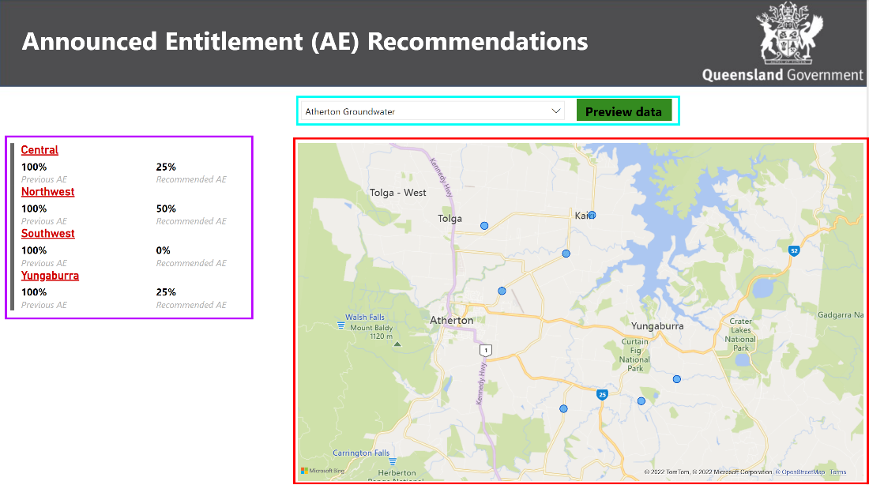

Figure 1: Landing Page

## Area Selection Dropdown with Preview Button

(See Figure 1, ■ )

* Dropdown Slicer:
  + The default starting value is Atherton, this drop down allows selection of the management areas (within scope) across Queensland. By selecting another management area, the page will be filtered to the selected management area.
* Preview button:
  + Once a management area has been selected by pressing the preview button, the management area information page with be displayed.

## Current vs recommended Announced entitlement Table

(See Figure 1, ■)

* The “Previous AE” displays historical data. This displays the latest data.
  + Note: This function currently uses the data from an old SharePoint export (File: Associated Data>AE History). This export contains a limited amount of data with old dates that may not coincide with the Recommended AE (Currently not appropriate for making AE decisions)
* The recommended displays the current calculated AE base on zone, or, if filtered by a bore on the map, it displays the AE for that bore for all zone that use it. This displays the latest data.
* By selecting the three dots at the top of the table you can export the data to a .csv file. (See figure 2)
  + Note: the data exported will be impacted by any filtering.

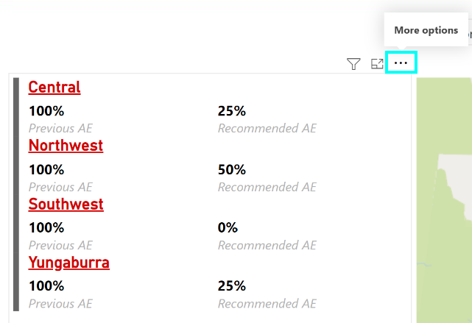

Figure 2: More options button on the multi-row card.

## Management Area Map

(See Figure 1, ■)

* The map will display the management area selected with all indicator bores highlighted.
* By selecting a zone within the announced entitlement table, the map will zoom the selected zone and only highlight bore with that zone.
* alternative you can click on a bore within the map which will highlight what zone it is part of and display the bore calculated AE values in the table. In the rare cases that the bore is used in more than one zone, all zones that use that bore will be highlighted.
  + Note: filtering by the map can be hard to distinguish, when exporting data from the AE table please ensure the check filtering.

# Area Information

This page is use to inspect a management area in greater detail, but still at a high level.  
  
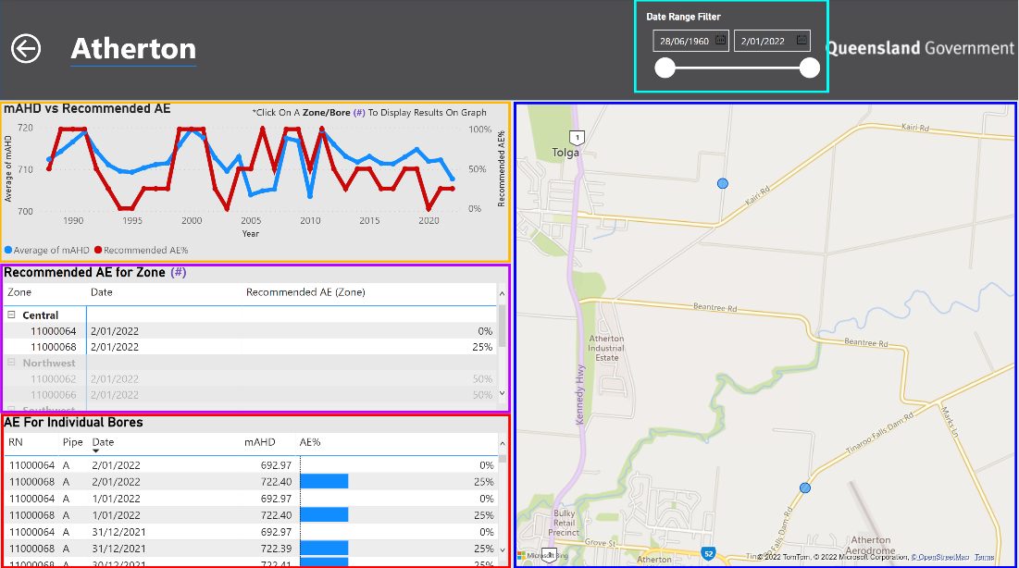

Figure 3: The Area Information Page

## Date Range Slicer

(See Figure 3, ■)

* This slicer can be used to filter the displayed data from a particular time period. If filtered, displays the latest data within the date range if data exists. If not, no data will be retrieved.
  + Note: there is no historical records of the rule in place and therefore all calculation are based on current rules and if no data exists this can cause an error across the page, removing the title and other displayed data. To rectify this reset the data range filter.

## MAHD vs Recommended AE Graph

(See Figure 3, ■)

* This graph by default displays the average of the mAHD for the entire management area and therefore may not be particularly helpful.
* This graph can be filtered to show zone historic mAHD and AE data by selecting a zone or bore from the Recommended AE for zone table, alternatively you can use the map to display historic data for a single bore.
  + Hover your mouse cursor over the graph to display a tool tip of the values of the mAHD/Recommended AE for the year the cursor is hovering over.
  + Note: using the AE for induvial bore table will not work as the dates in the table also affect the page filtering.

## Recommended AE for Zone Table

(See Figure 3, ■ )

* This table displays calculated and recommend AE for each zone
* This tale can be used to filter the page to zone or bore level, this included zooming the map and display historic data in the graph.
* This filtering can be used to identify trends.

## AE for Individual Bores Table

(See Figure 3, ■ )

* Based on the data range filter, this table displays mAHD and AE percentages if data exists within date ranges for the management area.
  + Note: AE calculations are based on current rules, there is no historic rules currently.

## Management Area Map

(See Figure 3, ■ )

* This map functions the same as the map located on the landing page.
* The map will display the management area that was set on the landing page by default.
* By selecting a zone or bore within the recommended AE for zone table, the map will zoom the selected zone or bore respectively and filter the page accordingly.
* You can click on a bore within the map which will filter the page accordingly.

# Quality Assurance

The quality Assurance page is used to display additional data of the selected Zone/bore/date, depending on the filters applied through the ‘drill through’.   
  
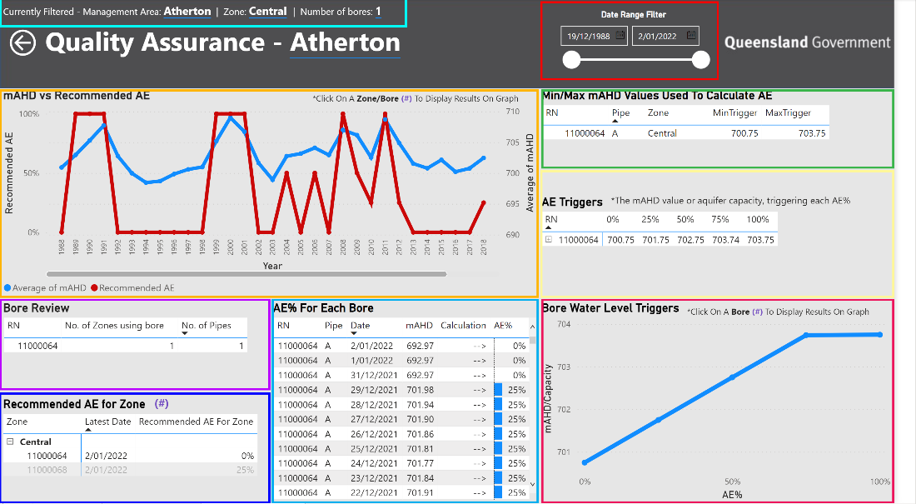

Figure 4: Quality Assurance Page

* To access and filter this page by just zone, right-click on a zone name within the Recommended AE for Zone table, and selected drill through to Quality assurance page. (See Figure 5)
* To access and filter this page by just zone and bore, right-click on a bore within the Recommended AE for Zone table, and selected drill through to Quality assurance page.
* To access and filter this page by zone, bore and date, right-click on a bore within the “AE for individual bores” table, and selected drill through to Quality assurance page.

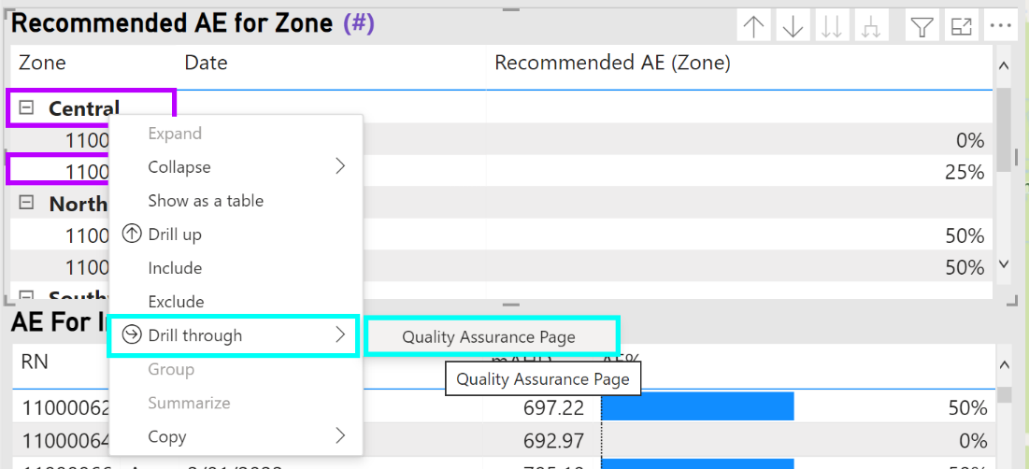

Figure 5: Process to open the QA page

Currently Filtered Indicator  
(See Figure 4, ■ )

This indicator shows the filters that are currently applied to the page. This is dependant on the selected “drill through” used.

## Date Range Slicer

(See Figure 4, ■ )

* This slicer can be used to filter the displayed data from a particular time period. If filtered, displays the latest data within the date range if data exists. If not, no data will be retrieved.
  + Note: there is no historical records of the rule in place and therefore all calculation are based on current rules and if no data exists this can cause an error across the page, affecting the displayed data. To rectify this reset the data range filter.

## mAHD vs Recommended AE Graph

(See Figure 4, ■ )

* This graph by default displays the average of the mAHD based on the filtering option to reach this page.
  + Hover your mouse cursor over the graph to display a tool tip of the values of the mAHD/Recommended AE for the year the cursor is hovering over.
  + Note: using the AE for induvial bore table will not work as the dates in the table also affect the page filtering. filtering this page by any table can have unintended errors in the graph. Remove all filtering on this page to rectify this.

## Bore Review

(See Figure 4, ■ )

* This just displays the number of zones that use this bore. And how many pipes it has.

## Recommended AE for Zone

(See Figure 4, ■ )

* This table acts in the same way as it does in Area.

## AE% for each Bore

(See Figure 4, ■ )

* This table acts in the same way as it does in Area information page but has an added column that displays a capacity calculation for management areas that uses capacity.

## Min/Max mAHD Values Used to Calculate AE

(See Figure 4, ■ )

* This table display min and max set elevations used in the capacity calculation. This is only used by some management areas.

## AE Triggers

(See Figure 4, ■ )

* This table displays the mAHD value or the aquifer capacity triggering each AE percentage.

## Bore Water Level Triggers Graph

(See Figure 4, ■ )

* This graph is a visual representation of the AE trigger tables data. For areas that do not use capacity the left-hand edge is just mAHD values. If the Area uses capacity, it is the capacity percentage.
* To use this graph, select the bore in the “Recommended AE for Zone” table.

Salt Water Intrusion (SWI)  
The SWI page is used to get additional information of the selected salt water intrusion Zone/Bore. This page will successfully display information only if the Zone selected contains SWI bore/s, or if the Individual Bore selected is a SWI bore.  
  
Figure 6: This is the SWI page with additional data for Quality Assurance

* To access and filter this page by just zone, right-click on a zone name within the Recommended AE for Zone table (Needs to be a zone that contains bore/s that is SWI; SWI = “True” displayed on the table), and selected drill through to SWI. (See Figure 7 and Figure 8)
* To access and filter this page by bore, right-click on a bore within the Recommended AE for Zone table (Needs to be a bore that is SWI; SWI = “True” displayed on the table), and selected drill through to SWI. (See Figure 7 and Figure 8)
* Alternatively, you can access the SWI page through the Quality Assurance page by the Recommended AE table (Needs to contain bore/s that is SWI; SWI = “True” displayed on the table).

Figure 7: To identify a SWI bore, look at the SWI column for a ‘True’. The red boxes indicate non-SWI bores and the blue boxes indicate SWI bores.

Figure 8: The steps to navigate through to the SWI page.

Currently Filtered Indicator  
(See Figure 6, ■ )

This indicator shows the filters that are currently applied to the page. This is dependent on the selected “drill through” used.

## Date Range Slicer

(See Figure 6, ■ )

* This slicer can be used to filter the displayed data from a particular time period. If filtered, displays the latest data within the date range if data exists. If not, no data will be retrieved.

## SWI Information table

(See Figure 6, ■ )

This table can provide the user with multiple in-depth information such as Date, SWI adjustment type, recorded Conductivity, the trigger value and a resulting indication/action.

# Data

This section is about how the data was put together using the Ground water database and the provided spreadsheets from the business.

Bore Register – SQL script to get RN, PIPE, MEAS_POINT, ELEVATION, RDATE, GIS_LAT, GIS_LNG. The data is gathered from the Ground Water Database using the ELEVATIONS, REGISTRATION tables.

SELECT REGISTRATION.RN, ELEVATIONS.PIPE, ELEVATIONS.MEAS_POINT, ELEVATIONS.ELEVATION, ELEVATIONS.RDATE, REGISTRATION.GIS_LAT, REGISTRATION.GIS_LNG

FROM ELEVATIONS, REGISTRATION

WHERE REGISTRATION.RN = ELEVATIONS.RN

Water Levels – SQL script to get the RN, RDATE, PIPE, MEAS_POINT, MEASURMENT, mAHD (This is calculated using Elevation + MEASURMENT). The data is gathered from the ground water database and a table that we created with only the indicator bore the tables are [Indicator Bore], WATER_LEVELS.

All the extra tables we made are on the associated data.xlsx



SELECT DISTINCT [Indicator Bore].RN, WATER_LEVELS.RDATE, WATER_LEVELS.PIPE, WATER_LEVELS.MEAS_POINT, WATER_LEVELS.MEASUREMENT, CAST([Indicator Bore].Elevation AS float) + CAST(WATER_LEVELS.MEASUREMENT AS float) AS mAHD

FROM [Indicator Bore], WATER_LEVELS

WHERE [Indicator Bore].RN = WATER_LEVELS.RN

Other Measurements - SQL script to get the RN, RDAT, PIPE, DEPTH, CONDUCT, Conduct Primary, Primary test, Conduct Secondary, secondary Test

Conduct – This is the conduct from WATER_QUALITY_FIELD from the ground water database.

Conduct primary – This is the 1st salt water intrusion trigger value

Primary test – This is checking if the conduct is less than the primary trigger value

Conduct Secondary – This is the 2st salt water intrusion trigger value

Secondary test – This is checking if the conduct is less than the Secondary trigger value

Tables SWI Bores Conduct, SQL_SWI_TRIGGERS are from the associated data.xlsx

SELECT [SWI Bores Conduct].RN,[RDATE],[SWI Bores Conduct].PIPE,[DEPTH],[SWI Bores Conduct].CONDUCT,[SQL_SWI_TRIGGERS].[Conduct Primary],

CASE WHEN ([SWI Bores Conduct].CONDUCT <= [SQL_SWI_TRIGGERS].[Conduct Primary]) THEN 'PASS'

WHEN ([SWI Bores Conduct].CONDUCT >= [SQL_SWI_TRIGGERS].[Conduct Primary]) THEN 'ATTENTION'

ELSE 'N/A'

END AS 'Primary Test',[SQL_SWI_TRIGGERS].[Conduct Secondary],

CASE WHEN ([SWI Bores Conduct].CONDUCT <= [SQL_SWI_TRIGGERS].[Conduct Secondary] ) THEN 'PASS'

WHEN ([SWI Bores Conduct].CONDUCT >= [SQL_SWI_TRIGGERS].[Conduct Secondary] ) THEN 'ATTENTION'

ELSE 'N/A'

END AS 'Secondary Test'

FROM [SWI Bores Conduct], [SQL_SWI_TRIGGERS]

WHERE [SWI Bores Conduct].RN = [SQL_SWI_TRIGGERS].RN

ORDER BY [SWI Bores Conduct].RN, [Primary Test]